UNIVERSITY INSTITUTE OF COMPUTING
PROJECT REPORT
ON
Online Trending Analyzer
Program Name: BCA
Data Interpretation Lab

SUBMITED BY:

NAME : DOREEN PETER ISDORY UID : 23BCA10393
BRANCH :BCA Section/ Group: 3A
Semester : 6 D.O.SUBMITION : ____________________

SUBMITED TO:
NAME :

DESIGINATION:
SIGN: ____________________


BONAFIDE CERTIFICATE

Certified that this project report “ONLINE TRENDING ANALYZER” is the Bonafide work of” DOREEN PETER ISDORY” under UID “23BCA10393” who carried out the project work under my supervision.

………………………………………
SIGNATURE
UIC DEPARTMENT
ASSISTANT PROFESSOR
RAJAT KAPOOR

DATA INTERPRETATION LAB

ONLINE TRENDING ANALYZER

1. Aim of the Project
The aim of this project is to design and develop a smart inventory dashboard for an online shopping system that analyzes product data, monitors stock levels, and identifies trending products using interactive visualizations.
2. Performing Tasks
Introduction
This project is a web-based application developed using Flask and SQLite. It provides a centralized dashboard where users can monitor product inventory, analyze sales trends, and make data-driven decisions. The dashboard uses charts and alerts to present data in a clear and interactive way.
Objectives
- To build a dynamic dashboard for inventory monitoring
- To analyze product popularity using views and sales
- To visualize data using bar, line, pie, and doughnut charts
- To detect low stock items and generate alerts
- To create a modern and user-friendly interface
Tools and Technologies Used
- Frontend: HTML, CSS, Chart.js
- Backend: Python (Flask Framework)
- Database: SQLite
- IDE: Visual Studio Code
3. Steps Included
- Create project folder and setup Flask environment
- Design database using SQLite
- Create products table and insert sample data
- Develop backend using Flask (app.py)
- Fetch data from database
- Implement logic for trending products and alerts
- Design frontend dashboard using HTML and CSS
- Integrate charts using Chart.js
- Display data in tables and charts
- Run and test the application
4. Algorithm / Logic / Flowchart
Algorithm
- Start
- Initialize database
- Fetch product data from database
- For each product:
  - Calculate trending score = views + (2 × sales)
  - Check if stock is low
  - Identify top trending product
  - Generate alerts if needed
- Send data to frontend
- Display charts and table
- End

5. Code Overview
Backend (Flask - app.py)
- Handles routing and server logic
- Connects to SQLite database
- Fetches and processes product data
- Calculates KPIs (total products, low stock, top product)
- Sends data to HTML template
Frontend (index.html)
- Displays dashboard UI
- Shows KPI cards
- Displays product table
- Renders charts using Chart.js
- Applies dark theme styling and animations
6. Output
The output of the project is a web-based dashboard displayed in the browser.
It includes:
- KPI cards (Total Products, Low Stock, Top Product)
- Bar chart (Stock Levels)
- Line chart (Sales Trend)
- Pie chart (Stock Distribution)
- Doughnut chart (Demand Distribution)
- Inventory table
- Alerts section
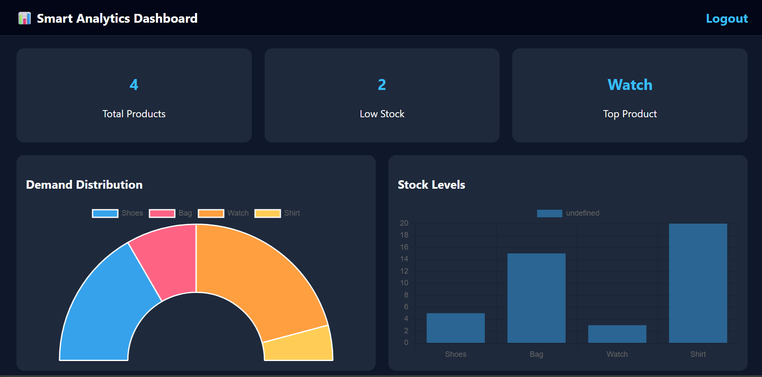
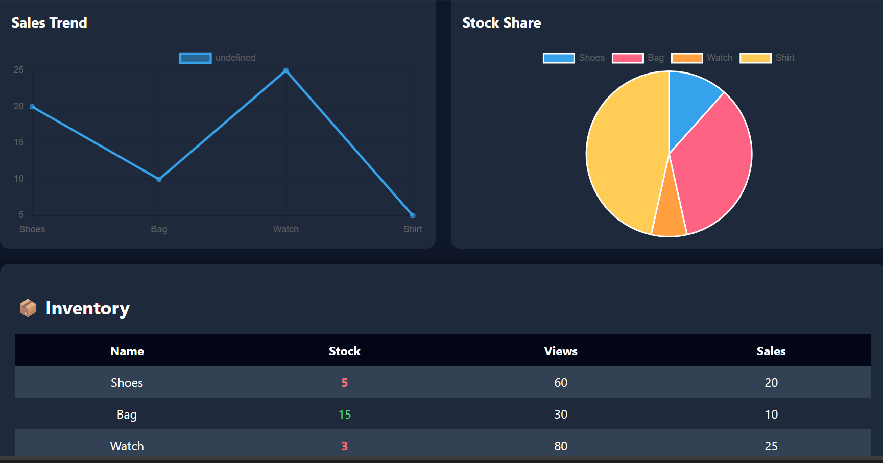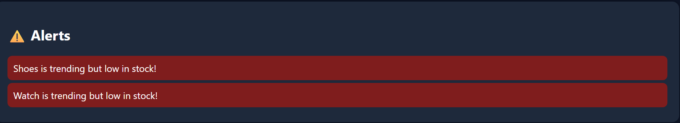

7. Conclusion
The project successfully demonstrates how data can be analyzed and visualized using a web dashboard. It helps in understanding product trends and inventory status effectively. The system is simple, efficient, and can be extended further for real-world applications such as e-commerce analytics and business decision-making.
8. Learning Outcomes
- Learned how to build a web application using Flask
- Gained knowledge of database management using SQLite
- Understood data visualization using Chart.js
- Improved frontend design skills using HTML and CSS
- Learned how to integrate backend with frontend
- Developed problem-solving and analytical thinking skills
- Gained experience in creating real-world mini projects
9. Screenshots

Link for Linkedin: https://www.linkedin.com/feed/update/urn:li:share:7446781565734596609/

Screenshot of Linkedin Post.

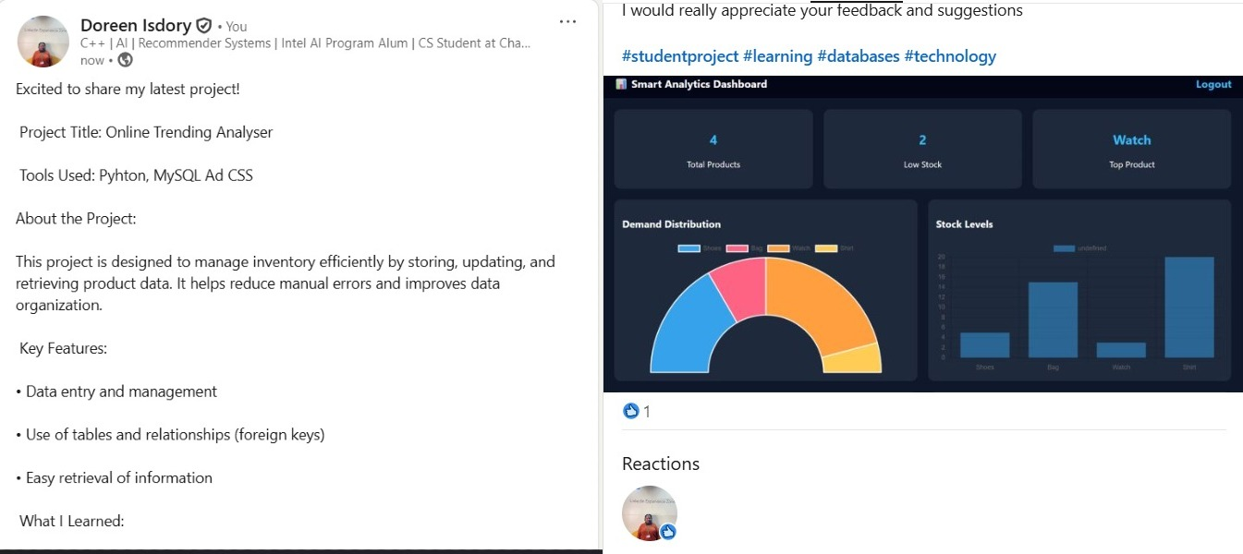

Screenshot for github

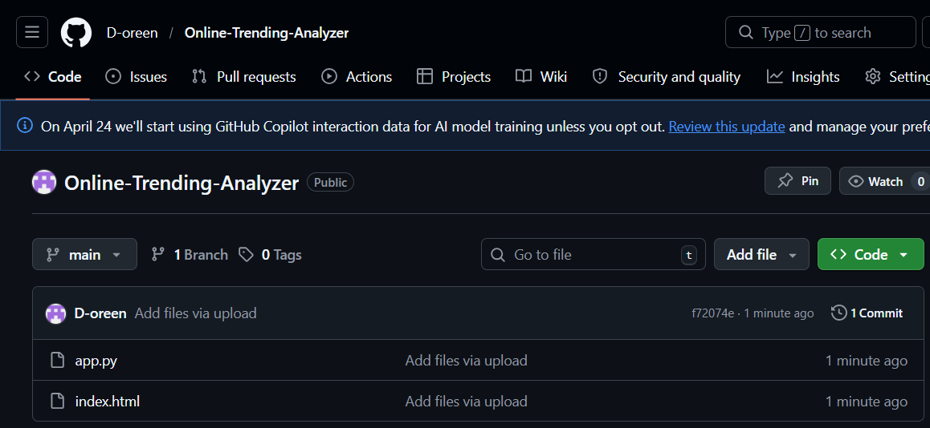

Link of Github: https://github.com/D-oreen/Online-Trending-Analyzer

Portifolio Link: https://drive.google.com/drive/folders/1CBvdDJ6nbf9oIJDoMdW8oJ4bd69NyHMp?usp=drive_link
Portifolio screenshot
